**DN 4.0 JAVA FSE SOLUTIONS – WEEK 5**

**SKILL: Microservices with Spring Boot 3 and**

**Spring Cloud**

**ADDITIONAL HANDS-ON**

**Create Eureka Discovery Server and register microservice:**

**Create and Launch Eureka Discovery Server -**

**EurekaDiscoveryServerApplication.java:**

package com.cognizant.eureka_discovery_server;  
import org.springframework.boot.SpringApplication;  
import org.springframework.boot.autoconfigure.SpringBootApplication;  
import org.springframework.cloud.netflix.eureka.server.EnableEurekaServer;  
@SpringBootApplication  
@EnableEurekaServer  
public class EurekaDiscoveryServerApplication {  
 public static void main(String[] args) {  
 SpringApplication.*run*(EurekaDiscoveryServerApplication.class, args);  
 }  
}

**application.properties:**

spring.application.name=eureka-discovery-server  
server.port=8761  
eureka.client.register-with-eureka=false  
eureka.client.fetch-registry=false  
logging.level.com.netflix.eureka=OFF  
logging.level.com.netflix.discovery=OFF

**pom.xml:**

<?xml version="1.0" encoding="UTF-8"?>  
<project xmlns="http://maven.apache.org/POM/4.0.0" xmlns:xsi="http://www.w3.org/2001/XMLSchema-instance"  
 xsi:schemaLocation="http://maven.apache.org/POM/4.0.0 https://maven.apache.org/xsd/maven-4.0.0.xsd">  
 <modelVersion>4.0.0</modelVersion>  
 <parent>  
 <groupId>org.springframework.boot</groupId>  
 <artifactId>spring-boot-starter-parent</artifactId>  
 <version>3.5.3</version>  
 <relativePath/> <!-- lookup parent from repository -->  
 </parent>  
 <groupId>com.cognizant</groupId>  
 <artifactId>eureka-discovery-server</artifactId>  
 <version>0.0.1-SNAPSHOT</version>  
 <name>eureka-discovery-server</name>  
 <description>Demo project for Spring Boot</description>  
 <url/>  
 <licenses>  
 <license/>  
 </licenses>  
 <developers>  
 <developer/>  
 </developers>  
 <scm>  
 <connection/>  
 <developerConnection/>  
 <tag/>  
 <url/>  
 </scm>  
 <properties>  
 <java.version>21</java.version>  
 <spring-cloud.version>2025.0.0</spring-cloud.version>  
 </properties>  
 <dependencies>  
 <dependency>  
 <groupId>org.springframework.cloud</groupId>  
 <artifactId>spring-cloud-starter-netflix-eureka-server</artifactId>  
 </dependency>  
 <dependency>  
 <groupId>org.springframework.boot</groupId>  
 <artifactId>spring-boot-starter-test</artifactId>  
 <scope>test</scope>  
 </dependency>  
 </dependencies>  
 <dependencyManagement>  
 <dependencies>  
 <dependency>  
 <groupId>org.springframework.cloud</groupId>  
 <artifactId>spring-cloud-dependencies</artifactId>  
 <version>${spring-cloud.version}</version>  
 <type>pom</type>  
 <scope>import</scope>  
 </dependency>  
 </dependencies>  
 </dependencyManagement>  
 <build>  
 <plugins>  
 <plugin>  
 <groupId>org.springframework.boot</groupId>  
 <artifactId>spring-boot-maven-plugin</artifactId>  
 </plugin>  
 </plugins>  
 </build>  
</project>

**Output:**

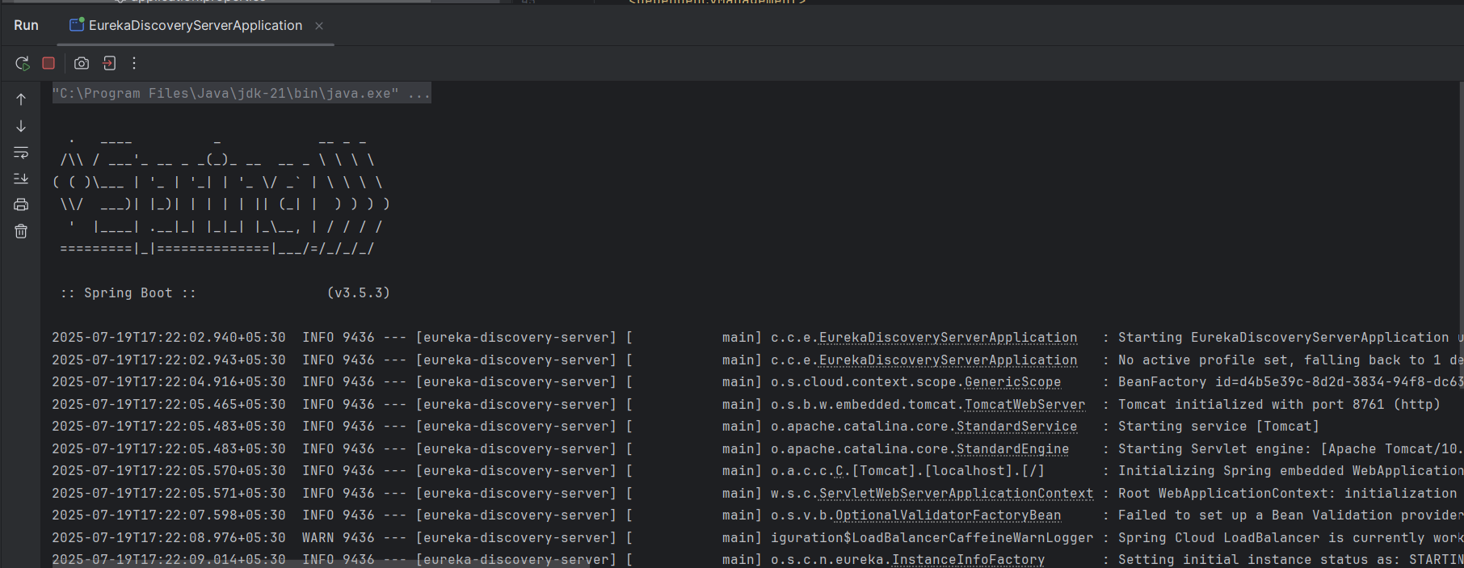

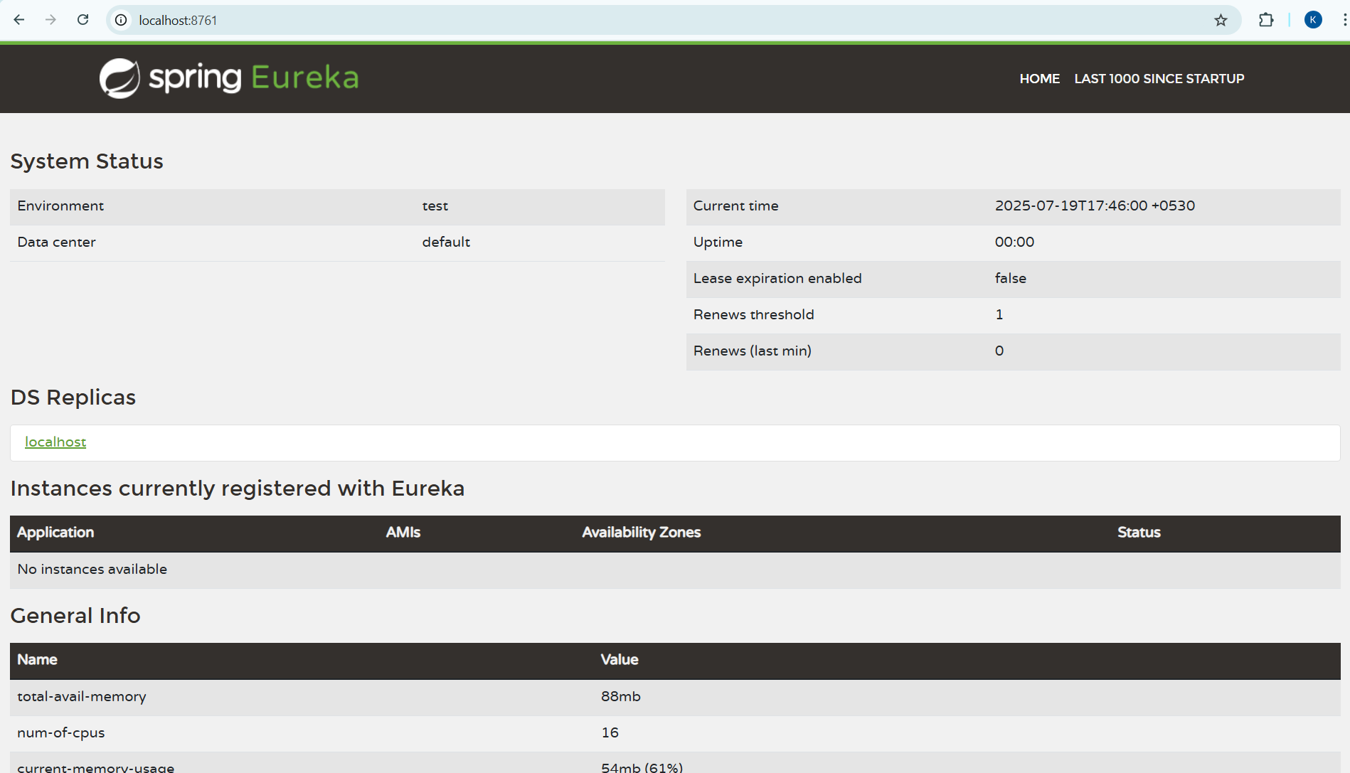

**Register Account REST API to eureka discovery-**

**AccountApplication.java:**

package com.cognizant.account;  
import org.springframework.boot.SpringApplication;  
import org.springframework.boot.autoconfigure.SpringBootApplication;  
import org.springframework.cloud.client.discovery.EnableDiscoveryClient;  
  
@SpringBootApplication  
@EnableDiscoveryClient  
public class AccountApplication {  
 public static void main(String[] args) {  
 SpringApplication.*run*(AccountApplication.class, args);  
 }  
}

**application.properties:**

server.port=8081  
spring.application.name=account-service  
eureka.client.service-url.defaultZone=http://localhost:8761/eureka

**pom.xml:**

<?xml version="1.0" encoding="UTF-8"?>  
<project xmlns="http://maven.apache.org/POM/4.0.0" xmlns:xsi="http://www.w3.org/2001/XMLSchema-instance"  
 xsi:schemaLocation="http://maven.apache.org/POM/4.0.0 https://maven.apache.org/xsd/maven-4.0.0.xsd">  
 <modelVersion>4.0.0</modelVersion>  
 <parent>  
 <groupId>org.springframework.boot</groupId>  
 <artifactId>spring-boot-starter-parent</artifactId>  
 <version>3.2.5</version>  
 <relativePath/> <!-- lookup parent from repository -->  
 </parent>  
 <groupId>com.cognizant</groupId>  
 <artifactId>account</artifactId>  
 <version>0.0.1-SNAPSHOT</version>  
 <name>account</name>  
 <description>Demo project for Spring Boot</description>  
 <url/>  
 <licenses>  
 <license/>  
 </licenses>  
 <developers>  
 <developer/>  
 </developers>  
 <scm>  
 <connection/>  
 <developerConnection/>  
 <tag/>  
 <url/>  
 </scm>  
 <properties>  
 <java.version>21</java.version>  
 <spring-cloud.version>2023.0.1</spring-cloud.version>  
 </properties>  
 <dependencies>  
 <dependency>  
 <groupId>org.springframework.cloud</groupId>  
 <artifactId>spring-cloud-starter-netflix-eureka-client</artifactId>  
 </dependency>  
 <dependency>  
 <groupId>org.springframework.boot</groupId>  
 <artifactId>spring-boot-starter-web</artifactId>  
 </dependency>  
 <dependency>  
 <groupId>org.springframework.boot</groupId>  
 <artifactId>spring-boot-devtools</artifactId>  
 <scope>runtime</scope>  
 <optional>true</optional>  
 </dependency>  
 <dependency>  
 <groupId>org.springframework.boot</groupId>  
 <artifactId>spring-boot-starter-test</artifactId>  
 <scope>test</scope>  
 </dependency>  
 </dependencies>  
 <dependencyManagement>  
 <dependencies>  
 <dependency>  
 <groupId>org.springframework.cloud</groupId>  
 <artifactId>spring-cloud-dependencies</artifactId>  
 <version>${spring-cloud.version}</version>  
 <type>pom</type>  
 <scope>import</scope>  
 </dependency>  
 </dependencies>  
 </dependencyManagement>  
 <build>  
 <plugins>  
 <plugin>  
 <groupId>org.springframework.boot</groupId>  
 <artifactId>spring-boot-maven-plugin</artifactId>  
 </plugin>  
 </plugins>  
 </build>  
</project>

**Output:**

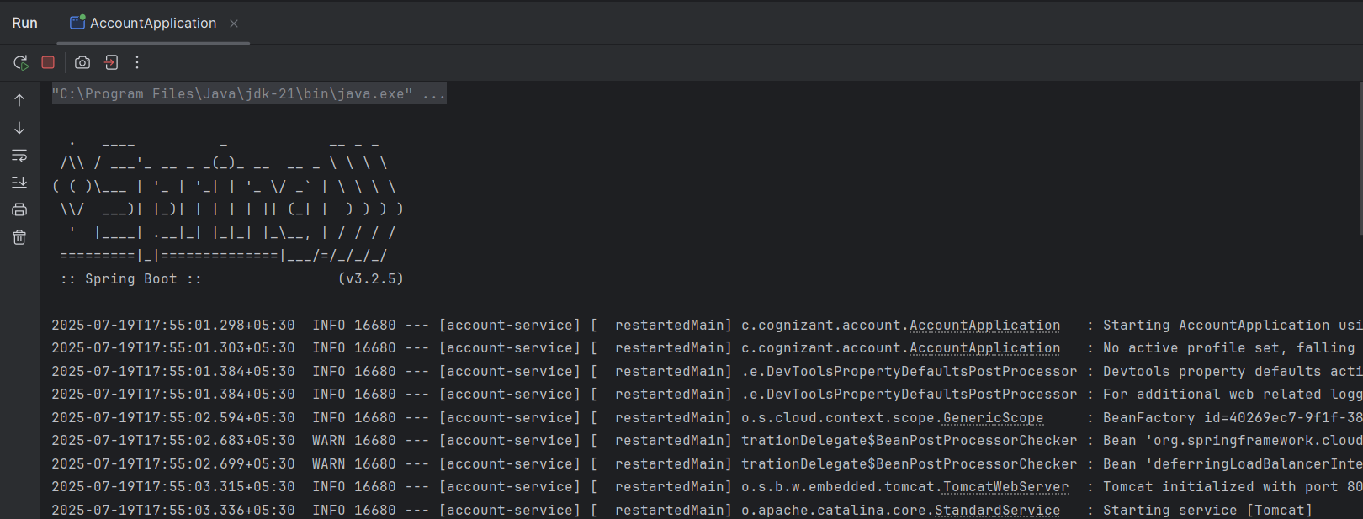

**Register Loan REST API to eureka discovery-**

**LoanApplication.java:**

package com.cognizant.loan;  
import org.springframework.boot.SpringApplication;  
import org.springframework.boot.autoconfigure.SpringBootApplication;  
import org.springframework.cloud.client.discovery.EnableDiscoveryClient;

@SpringBootApplication  
@EnableDiscoveryClient  
public class LoanApplication {  
 public static void main(String[] args) {  
 SpringApplication.*run*(LoanApplication.class, args);  
 }  
}

**application.properties:**

spring.application.name=loan-service  
server.port=8082  
eureka.client.service-url.defaultZone=http://localhost:8761/eureka

**pom.xml:**

<?xml version="1.0" encoding="UTF-8"?>  
<project xmlns="http://maven.apache.org/POM/4.0.0" xmlns:xsi="http://www.w3.org/2001/XMLSchema-instance"  
 xsi:schemaLocation="http://maven.apache.org/POM/4.0.0 https://maven.apache.org/xsd/maven-4.0.0.xsd">  
 <modelVersion>4.0.0</modelVersion>  
 <parent>  
 <groupId>org.springframework.boot</groupId>  
 <artifactId>spring-boot-starter-parent</artifactId>  
 <version>3.2.5</version>  
 <relativePath/> <!-- lookup parent from repository -->  
 </parent>  
 <groupId>com.cognizant</groupId>  
 <artifactId>account</artifactId>  
 <version>0.0.1-SNAPSHOT</version>  
 <name>account</name>  
 <description>Demo project for Spring Boot</description>  
 <url/>  
 <licenses>  
 <license/>  
 </licenses>  
 <developers>  
 <developer/>  
 </developers>  
 <scm>  
 <connection/>  
 <developerConnection/>  
 <tag/>  
 <url/>  
 </scm>  
 <properties>  
 <java.version>21</java.version>  
 <spring-cloud.version>2023.0.1</spring-cloud.version>  
 </properties>  
 <dependencies>  
 <dependency>  
 <groupId>org.springframework.cloud</groupId>  
 <artifactId>spring-cloud-starter-netflix-eureka-client</artifactId>  
 </dependency>  
 <dependency>  
 <groupId>org.springframework.boot</groupId>  
 <artifactId>spring-boot-starter-web</artifactId>  
 </dependency>  
 <dependency>  
 <groupId>org.springframework.boot</groupId>  
 <artifactId>spring-boot-devtools</artifactId>  
 <scope>runtime</scope>  
 <optional>true</optional>  
 </dependency>  
 <dependency>  
 <groupId>org.springframework.boot</groupId>  
 <artifactId>spring-boot-starter-test</artifactId>  
 <scope>test</scope>  
 </dependency>  
 </dependencies>  
 <dependencyManagement>  
 <dependencies>  
 <dependency>  
 <groupId>org.springframework.cloud</groupId>  
 <artifactId>spring-cloud-dependencies</artifactId>  
 <version>${spring-cloud.version}</version>  
 <type>pom</type>  
 <scope>import</scope>  
 </dependency>  
 </dependencies>  
 </dependencyManagement>

<build>  
 <plugins>  
 <plugin>  
 <groupId>org.springframework.boot</groupId>  
 <artifactId>spring-boot-maven-plugin</artifactId>  
 </plugin>  
 </plugins>  
 </build>

</project>

**Output:**

